ChoreScore User Manual

**This manual describes how to navigate and utilize the ChoreScore mobile application.**

# Introduction

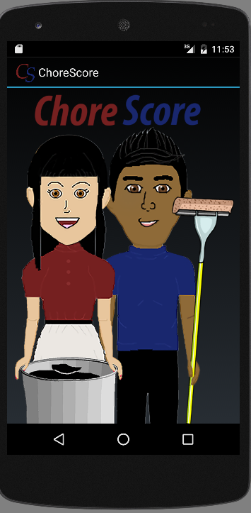

The ChoreScore app allows groups of people to delegate chores and have group members complete the chores to earn points within your group.

Each user creates their own account and upon login has the ability to create a new group or search for and join one that their friends/family have already created. The user may then select which group they wish to see details for by selecting it from the current groups page, making it their current default group.

Within the selected group, the group admin can create chores that need doing; assigning the chore a description, points and a due date. They or other members can complete these chores by submitting an image of the completed chore. Once a chore is completed the group admin can either accept it if it’s done to their satisfaction (award the completer points) or decline it if the chore was done unsatisfactorily (return the chore to the pending chores list). If the completed chore was declined members have the opportunity to do a better job on the chore and resubmit it for approval.

Members can redeem points in increments of 50, and upon redemption the administrator of the group will be sent a notification. The user would then be awarded depending on what that group had decided the award would be for the amount of points redeemed. This allows our users to assign value to the points in a way that suits their group, rather than forcing them to adhere to a fixed value such as a pre-defined monetary reward. Points are rewarded and redeemed within groups, so a single user may have different amounts of points in each group that they join.

# Home Page

This page will be displayed any time you start the application and you are not logged in.

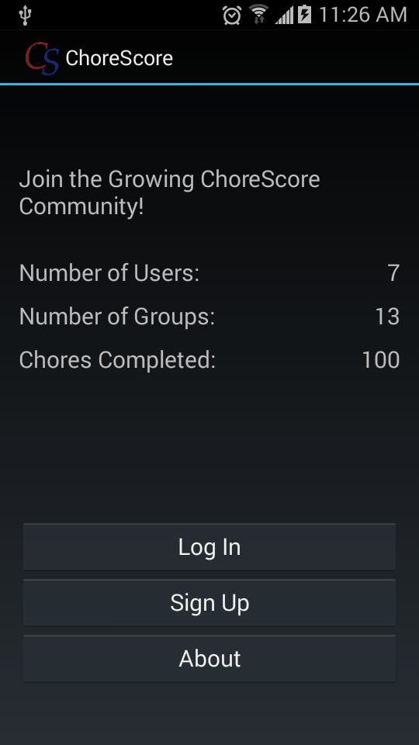

2. Log In

3. Sign Up

4. About

1. Application Stats

**1. Application Stats:** Displays stats on the use of our application including the total number of users, groups, and chores completed.

**2. Log In:** Tapping this button will bring you to the login form where you can log in if you have already registered your account.

**3. Sign Up:** Tapping this button will bring you to the sign up form where you can register your chore score account.

**4. About:** Tapping this button will bring up the about page, which provides a brief description of our app and a link to this manual.

# Current Groups Page

This page will be displayed after you log-in on the application and when you start the application and have logged in previously. It displays a list of the chore groups which you currently belong to, if any.

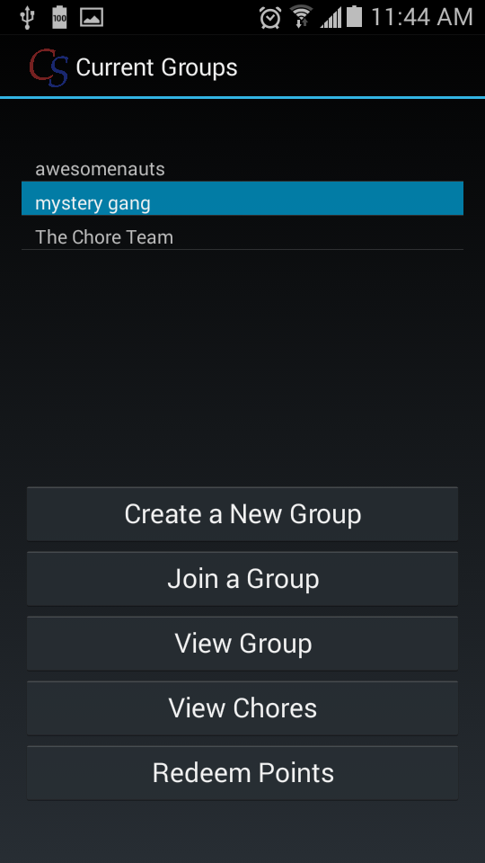

6. Redeem Points

5. View Chores

4. View Group

3. Join a Group

2. Create a New Group

1. List of Current Groups

**1. List of Current Groups:** A list of all the groups you belong to. The highlighted group represents your current default group, and you can change your default group by tapping on any of the groups in the list.

**2. Create a New Group:** Tapping this button will navigate to the form for creating a new group of your own.

**3. Join a Group:** Tapping this button will navigate to the form for finding and joining an existing group.

**4. View Group:** Tapping this button will navigate to the 'Group Details' page for your currently selected default group.

**5. View Chores:** Tapping this button will navigate to the 'Pending Chores' page for your currently selected default group.

**6. Redeem Points:** Tapping this button will navigate to the 'Point Redemption' page for your currently selected default group.

# Create Group Page

This page allows you to create a new chore group for your household.

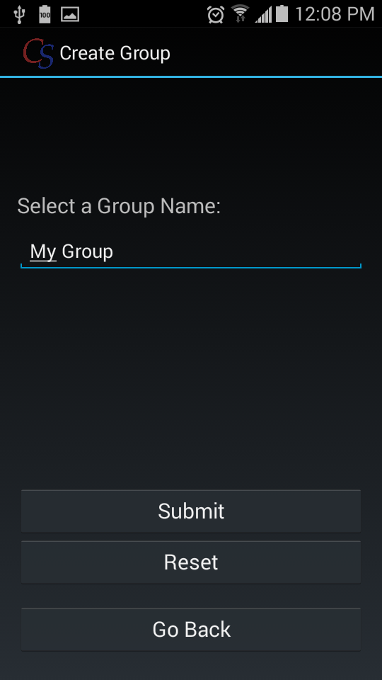

4. Go Back

3. Reset

2. Submit

1. Group Name

**1. Group Name:** This field allows you to input the name for the group which you are creating via keypad.

**2. Submit:** Tapping this button will attempt to create a new group with the name you have provided. If successful, you will automatically join the group and become the group admin.

**3. Reset:** Tapping this button will clear the fields on the form.

**4. Go Back:** Tapping this button will go back to the previous page.

# Join Group Page

This page allows you to search for and join and existing group.

3. Search Results

4. Go Back

2. Search

1. Search Field

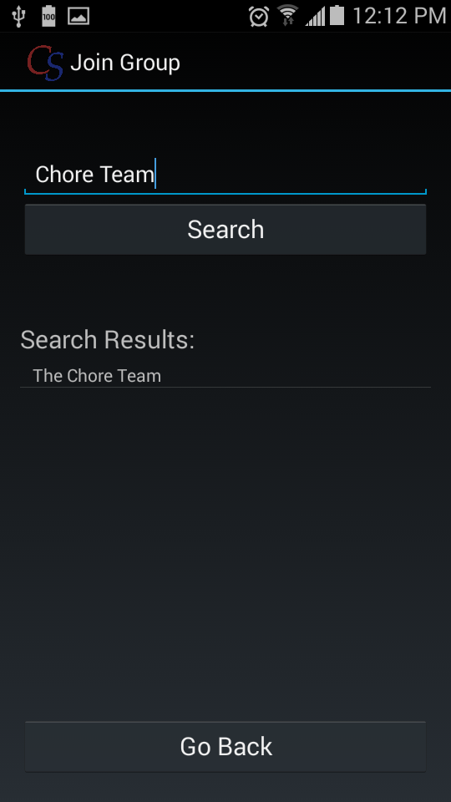

**1. Search Field:** This field allows you to input the name (or part of the name) of the group that you are looking for via keypad.

**2. Search:** Tapping this button will display a list of groups whose names match the input you have put in the search field.

**3. Search Results:** A list of groups which match your search criteria. Tapping on a group in this list will cause you to join the group if you haven't already.

**4. Go Back:** Tapping this button will go back to the previous page.

# Group Details Page

This page displays the members and admin for your current default group. You can leave your group from this page.

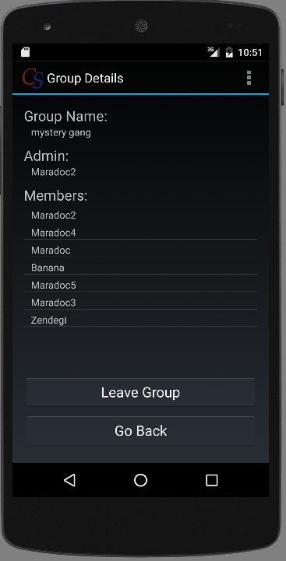

2. Leave Group

3. Go Back

1. Group Information

**1. Group Information:** Displays the group name, group admin, and list of members in the current group.

**2. Leave Group:** Tapping this button allows you to leave your current group. If you are the admin, another member will be automatically assigned as the new admin. If you are the only member in the group, it will be deleted. *WARNING: leaving a group will cause you to lose all of your points in that group.

**3. Go Back:** Tapping this button will go back to the previous page.

# Point Redemption Page

This page allows you to redeem any current points you have in your group. Once you redeem your points they will be taken out of your balance and the admin of your group will be sent a notification.

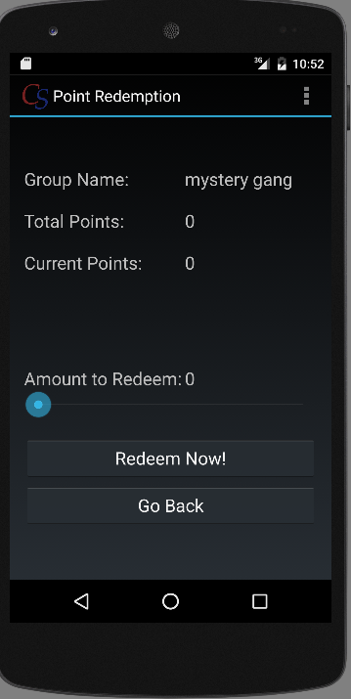

3. Amount to Redeem

4. Redeem Now

5. Go Back

2. Current Points

1. Total Points

**1. Total Points:** Displays how many points you have earned in total in the current group (includes all points which have been redeemed).

**2. Current Points:** Displays how many points you have remaining to spend in the current group.

**3. Amount to Redeem:** The number of points you wish to redeem. Can be adjusted in increments of 50 by sliding the slider to the right.

**4. Redeem Now:** Tapping this button will redeem the specified amount of points and notify your group admin that you have redeemed the points.

**Sample Notification** :

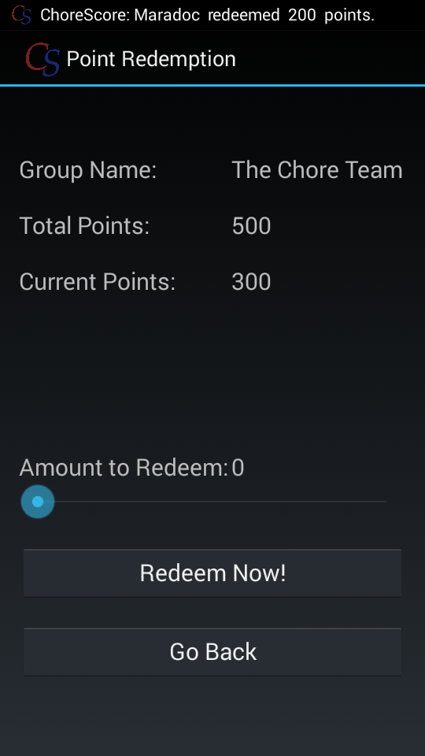

**5. Go Back:** Tapping this button will go back to the previous page.

# Pending Chores Page

This page displays all outstanding chores that have a due date past the current date. Here you can see which chores need to be done, and submit a request for points upon completion of a certain chore.

3. Review Completed Chores

2. Add Chore to List

4. Current Groups

1. Chore List

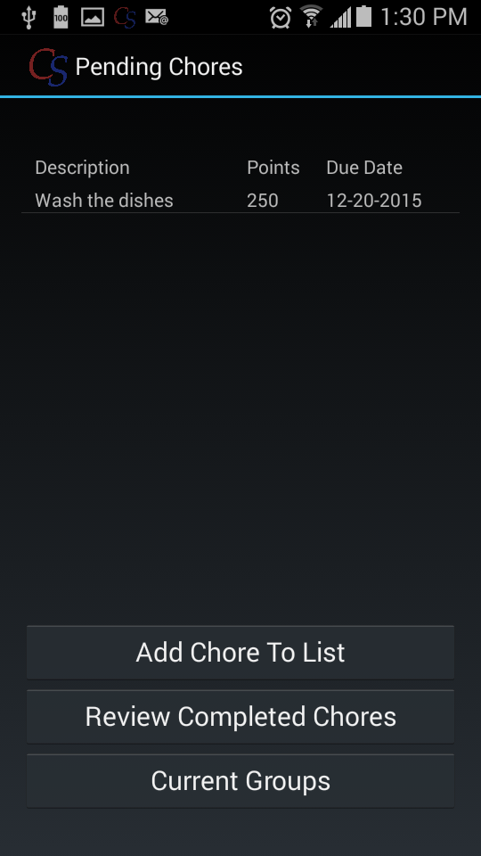

**1. Chore List:** A list of pending chores, their descriptions, their point values, and their due dates. Tapping one of these chores will prompt you to take a picture to show your completed work. The picture you take will be submitted with the chore so it can be reviewed by the admin and you can potentially earn points for completion.

**2. Add Chore to List:** Tapping this button will navigate to the Add Chore page to create a new pending chore.

**3. Review Completed Chores:** Tapping this button will navigate to the Review Chores page.

**4. Current Groups:** Tapping this button will return to the Current Groups page.

# Add Chore Page

This page allows the group admin to create new chores for the members of the group (themselves included) to complete.

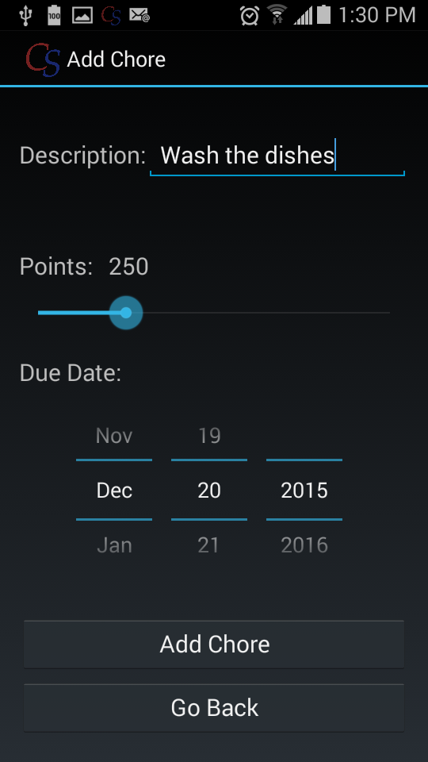

3. Due Date

4. Add Chore

5. Go Back

2. Points

1. Description

**1. Description:** A short, written description of the chore. This description will be displayed when the chore is added to the pending chores list.

**2. Points:** The number of points that will be rewarded for the completion of this chore. Can be incremented by 50 points by sliding the seek bar to the right.

**3. Due Date:** The date that the chore must be completed by. Can be set by scrolling the month, day, and year controls respectively. Cannot be set to a date in the past.

**4. Add Chore:** Adds the chore from the form to the pending chore list.

**5. Go Back:** Tapping this button will return to the previous page.

# Review Chore Page

This page allows the group admin to review chores submitted by group members. They can look at the proof of completion picture uploaded by the member who completed the chore and decide whether to approve the chore (giving the member points for completion) or deny the chore (putting it back on the pending chores list).

2. Go Back

1. Completed Chores List

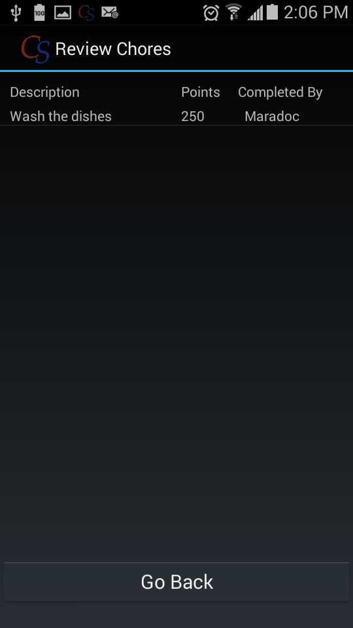

**1. Completed Chores List:** Tapping a chore on this list will open a dialog box that shows the image the member uploaded for that chore. The dialog box has two options, 'Deny' and 'Approve', and the admin can choose the appropriate option to approve or deny the chore as being properly complete. See sample dialog box below:

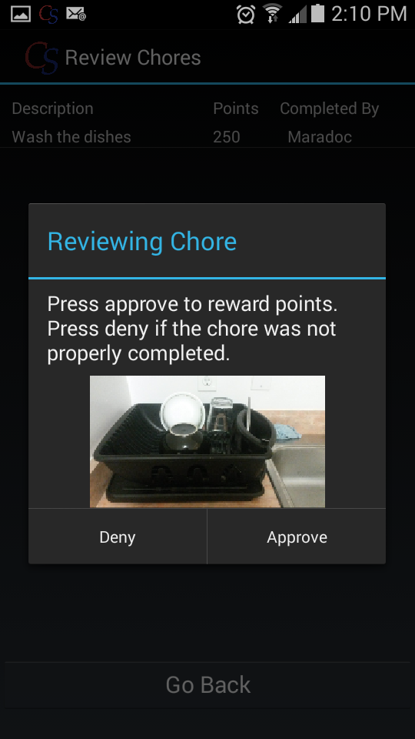

**2. Go Back:** Tapping this button will return to the previous page.